SIMATS ENGINEERING
Department of Computer Science and Engineering
CSA10 – SOFTWARE ENGINEERING
ASSIGNMENT 1 – CO1
Design, Simulate and Validate an Agile Delivery Strategy
for the Omnichannel Order Fulfilment Platform
CO1: Apply agile methodologies and project management techniques such as scale and lean to effectively manage software projects using industry-standard tools like Jira.
Student Name |  | Register Number
Department / Section |  | Academic Year / Semester
Faculty Name |  | Nature of Assignment | Individual
Duration | 1 Week | Total Marks | 50
Date of Submission |  | Date of Evaluation

MARK SHEET (Rubric-based Evaluation)
Task | Task Title | Max | Marks Awarded | Remarks
1 | Problem Investigation and Delivery Outcomes | 5
2 | Agile and Lean Operating Model | 6
3 | Prioritized Product Backlog (Jira / Selected Tool) | 8
4 | Capacity-Based Release Plan and Workflow | 7
5 | Delivery Simulation and Design Validation | 7
6 | Scaled Delivery Redesign and Validation (Day-4) | 12
7 | Individual Technical Reflection | 5
 | TOTAL | 50

OVERALL REMARKS

Student Signature | Faculty Signature | Program Director
Talla Jahnavi

MANDATORY SUBMISSION EVIDENCE CHECK
Task | Evidence Expected | Status | Note
1 | Investigation questions, stakeholder findings / simulated responses, problem statement, scope boundaries, feasibility, measurable success criteria
2 | Comparison of two approaches, justified selection, operating model with Lean practices, tool investigation & selection
3 | ≥4 epics, ≥12 user stories with AC, priorities, estimates, dependencies, DoR, DoD, stakeholder conflict decisions, tool screenshots/export
4 | Capacity assumptions, 4 sprint goals, selected work, estimation method, dependencies (gateway/scanner), workflow + WIP limits, urgent/unfinished rules
5 | Bottleneck prediction, ≥10 simulated events (labelled), tool updates, ≥3 delivery indicators, interpretation + improvement for next sprint
6 | Impact diagnosis, redesign objectives, revised backlog/roles/sequencing, scaled Agile practices, ≥5 further events, comparative indicators, defence
7 | Significant decision, evidence-driven change, remaining vulnerability, ethical concern addressed, next investigation linked to own artefacts

SUBMISSION CHECKLIST (not separately marked)
Requirement | Status
All tasks (1–7) answered with required evidence | ☐ Yes ☐ Partly ☐ No
Investigation questions + stakeholder / simulated findings present (Task 1) | ☐ Yes ☐ Partly ☐ No
Two delivery approaches compared and operating model justified (Task 2) | ☐ Yes ☐ Partly ☐ No
≥4 epics + ≥12 stories with AC, priorities, estimates, DoR/DoD (Task 3) | ☐ Yes ☐ Partly ☐ No
Capacity plan, sprint goals, workflow with WIP limits shown (Task 4) | ☐ Yes ☐ Partly ☐ No
Sprint-1 simulation: prediction, ≥10 events, indicators, improvement (Task 5) | ☐ Yes ☐ Partly ☐ No
Day-4 redesign: impact, objectives, revised strategy, validation, defence (Task 6) | ☐ Yes ☐ Partly ☐ No
Individual reflection covering decision, change, vulnerability, ethics, next step (Task 7) | ☐ Yes ☐ Partly ☐ No
Tool screenshots / export (backlog, board, workflow) included and labelled | ☐ Yes ☐ Partly ☐ No
All simulated data clearly labelled as simulated (not presented as real delivery) | ☐ Yes ☐ Partly ☐ No
No unfilled template placeholders; work consistent throughout | ☐ Yes ☐ Partly ☐ No
Viva readiness (able to defend prioritization, capacity, WIP, indicators) | ☐ Yes ☐ No

TASK 1 – INVESTIGATE THE PROBLEM AND DEFINE DELIVERY OUTCOMES
Investigate the platform from the perspectives of customers, warehouse pickers, support agents, finance reviewers and the development team.
- Formulate at least three questions to investigate about priorities, workflow problems or delivery constraints.
- Obtain initial evidence through a small stakeholder discussion, questionnaire or documented review of the existing process. If access is unavailable, use clearly identified simulated stakeholder responses.
- Define the product goal, first-release scope and exclusions.
- Establish at least three measurable delivery-success criteria.
- Examine technical, operational and financial feasibility at a level appropriate to project planning.
Evidence Expected
Investigation questions, stakeholder findings or labelled simulated responses, a problem statement, scope boundaries, feasibility observations and measurable success criteria.

1.1 Stakeholders and investigation questions
The investigation focuses on causes of operational failure and on the evidence needed to decide what can safely fit into the first release. The following questions are suitable for a short interview or process review:
1. At which point do displayed stock quantities differ from the quantity that warehouse staff can actually pick, and how often does this occur?
2. What information is missing when customers or support agents follow an order from checkout through dispatch and delivery?
3. Which refund conditions, amount limits and approval roles cause delays or unauthorized approvals?
4. What should the system do when the payment gateway is unavailable, times out or returns an uncertain response?
5. How are orders assigned to stores or warehouses, and what stock-reservation expiry rule is operationally acceptable?
6. Which order and refund events must finance reviewers be able to trace during reconciliation?

1.2 Initial evidence – simulated stakeholder discussion
Access to actual retailer stakeholders is not established in the assignment scenario. The following responses are therefore simulated to demonstrate how evidence would be recorded. They must not be represented as interviews with real employees.
Stakeholder | Simulated finding | Decision derived from the finding
Customer | Tracking remains at “processing” without a clear milestone. | Display customer-safe milestones such as paid, picked, dispatched and delivered.
Warehouse picker | A pick list may include an item that has already been allocated elsewhere. | Reserve stock atomically at checkout and show only valid reserved items on the pick list.
Support agent | Customers contact support repeatedly because return and refund progress is not visible. | Provide a support lookup view with order, return and refund status.
Finance reviewer | A large refund may be approved informally without a consistent audit trail. | Require role- and amount-based approval and preserve the decision, actor, time and reason.
Store manager | Store and warehouse stock ownership needs to be visible before an order is routed. | Keep stock location and fulfilment ownership with each reservation.
Development team | Gateway access is delayed and there is no established velocity. | Build a local payment adapter/stub first and treat the first sprint as a capacity-learning sprint.

1.3 Problem statement and product goal
The current process risks accepting orders against unavailable stock, losing visibility between payment and dispatch, delaying returns and refunds, and failing to show who owns each order. The product goal is to make every accepted synthetic order traceable from authenticated checkout through stock reservation, payment confirmation, picking, dispatch and delivery, and to support a return and authorized refund with an auditable history. Stock must never become negative, retries must not create duplicate payment intents, and each role must see only the information and actions it is authorized to use.

1.4 First-release scope and exclusions
Included in the first release | Deferred or excluded from the first release
Authenticated customer checkout and order creation. | Demand forecasting based on trained machine-learning models.
Stock reservation with expiry and rejection of unavailable stock. | Personalized recommendations and loyalty features.
Idempotent payment request, local order persistence and safe retry behaviour. | Multi-currency pricing and broad promotional campaign features.
Warehouse pick list for assigned, paid and reserved orders. | Full live production payment processing; sandbox and simulated adapters only.
Dispatch state changes and customer-visible tracking milestones. | Advanced sales analytics dashboard.
Customer return request and one controlled refund-approval workflow. | Unapproved automatic refunds or automatic stock corrections.
Support order lookup and fixed-threshold low-stock alert. | Unbounded regional customization beyond the two-region validation target.

The first release deliberately covers a coherent operational journey rather than attempting to deliver every proposed module superficially. The storefront, inventory, payment, fulfilment, tracking, returns, refunds and support capabilities are included at a minimum viable level. Advanced analytics and forecasting are deferred.

1.5 Measurable delivery-success criteria
Criterion | Acceptance threshold / repeatable test | Why it matters
End-to-end journey | Using synthetic data, one order reaches Delivered and a valid return reaches Refunded; every transition has actor, timestamp and audit record. | Demonstrates the complete order-to-refund goal.
Stock integrity | Run 100 concurrent test order attempts for an item with 10 available units. No more than 10 reservations succeed and stock never becomes negative. | Prevents overselling and failed picks.
Payment idempotency | Send 10 retries with the same payment idempotency key. Exactly one payment intent and one order are created. | Prevents duplicate charges and duplicate orders.
Authorization | A support-agent account cannot approve a refund; an authorized finance reviewer can approve only within the configured limit. | Protects financial control and accountability.
Tracking usability | A customer can read the permitted order milestones using keyboard navigation and screen-reader-readable labels. | Makes status information accessible.
Reproducible release | A clean checkout of the source and documented build instructions reproduce the core test journey; records persist after application restart. | Supports reliable deployment and verification.

These are proposed acceptance targets. They are not measured results and must be verified by repeatable tests before a real release.

1.6 Feasibility observations
Feasibility area | Assessment and condition
Technical | A transactional database, synthetic test data and a local payment adapter are feasible for a prototype. Payment idempotency, persistence and authorization need automated tests. Gateway sandbox access from week four is a dependency, not an assumption that it will always be available.
Operational | The workflow maps to existing customer, picker, support and finance responsibilities. Warehouse staff must approve reservation expiry and picking rules. Finance must approve refund limits and audit fields. Limited 90-minute weekly access requires prepared questions and concise demonstrations.
Financial | The plan assumes existing development computers and test accounts. Optional hosting, paid Jira capabilities, external gateway fees and scanner costs must be confirmed separately. No unsupported cost saving is claimed.
Schedule | Four two-week sprints are possible only if the team protects a narrow first-release scope, uses a provisional capacity limit and defers analytics and promotions.
People and governance | A seven-member team can cover product analysis, frontend, order API, inventory, payments/security, QA and DevOps. QA and payment integration are likely shared bottlenecks.

Task 1 conclusion: the most important delivery outcome is a reliable and auditable order journey. The simulated stakeholder evidence supports prioritizing stock integrity, tracking visibility and human-controlled refunds over advanced analytics.

TASK 2 – DESIGN AND JUSTIFY THE PROJECT-MANAGEMENT APPROACH
Develop two meaningfully different delivery approaches for the scenario. Consider Scrum, Lean flow management, XP practices or a justified combination.
- For each approach, explain how work would be selected, coordinated and reviewed.
- Identify its suitability for changing requirements and cross-functional work.
- Examine likely limitations, overheads and delivery risks.
- Select an approach and create a tailored operating model defining responsibilities, planning activities, review points, escalation procedures and stakeholder participation.
- Explain how Lean principles will help reduce waiting, unnecessary handovers, rework or excessive work in progress.
Evidence Expected
Comparison of two approaches, a justified selection and an original operating model with explicit Lean practices.

2.1 Comparison of two delivery approaches
Dimension | Scrum with Lean flow controls | Kanban with release milestones
Work selection | Product owner orders a backlog; the team selects ready stories against a sprint goal and capacity. | Team pulls the highest-value ready item when a WIP slot becomes available.
Coordination | Daily 15-minute coordination; refinement; sprint planning, review and retrospective. | Continuous flow review and regular replenishment; coordination is triggered by blocked work and service limits.
Review | A potentially usable increment is reviewed every two weeks with warehouse and finance stakeholders. | Stakeholders review delivered items weekly or at agreed service checkpoints.
Change response | Urgent work is negotiated; scope can change only if the sprint goal remains protected or work is exchanged. | Priorities can be reordered continuously, with a tightly controlled expedite lane.
Suitability | Strong fit for an eight-week deadline with four explicit increments and scarce stakeholder review windows. | Strong fit for support and operational maintenance where work arrives continuously.
Limitations | Without velocity, the team may overcommit; sprint boundaries can create pressure to hide unfinished work. | Without firm milestones, payment integration and the complete end-to-end journey may be delayed until late.

2.2 Selected approach and justification
The selected approach is Scrum with Lean flow controls. Four two-week sprints provide predictable checkpoints before the fixed festival-sale deadline. The product owner can make scope trade-offs at sprint boundaries, while warehouse and finance stakeholders can attend a prepared review within their 90-minute weekly availability. Lean WIP limits and blocked-work policies are added to prevent the sprint plan from hiding queues or unfinished work.
Pure Kanban would offer flexible reprioritization, but the fixed eight-week release and multiple dependent capabilities require explicit sprint goals and release milestones. Kanban practices remain useful for visualizing flow, limiting work in progress and managing blockers.

2.3 Tailored operating model and responsibilities
Role | Primary responsibility | Decision / evidence owned
Product and analysis lead | Owns product goal, backlog order, stakeholder questions and scope trade-offs. | Accepts priorities; resolves conflict; escalates blocked dependency after one working day.
Frontend engineer | Implements customer checkout, tracking and support-facing screens. | UI acceptance, keyboard navigation and readable status labels.
Order API engineer | Implements order creation, state transitions and service contracts. | Order lifecycle validation and API contract.
Inventory and data engineer | Implements stock reservation, expiry, stock records and low-stock rule. | Concurrency test and stock invariant evidence.
Payments and security engineer | Implements idempotent payment adapter, permissions and refund controls. | Payment retry and authorization evidence; handover documentation.
QA engineer | Defines test cases, executes functional, negative, concurrency and regression tests. | Can reject work that does not meet acceptance criteria; owns test evidence.
DevOps engineer | Maintains build, deployment, test environment and release traceability. | Repeatable build, health checks, deployment notes and release tag.

2.4 Cadence, review and escalation
Activity | Frequency / duration | Purpose
Daily coordination | 15 minutes each working day. | Identify progress, next action and blockers; no lengthy status reporting.
Backlog refinement | Weekly, within the stakeholder 90-minute window. | Clarify acceptance examples, dependencies, policy questions and story size.
Sprint planning | At the start of each two-week sprint. | Agree sprint goal and select only ready work within provisional capacity.
Sprint review | At the end of each sprint; include warehouse and finance representatives. | Demonstrate the working journey and record acceptance or change requests.
Retrospective | At the end of each sprint. | Select one or two measurable process improvements.
Technical/API design huddle | When a shared contract changes; time-boxed. | Resolve interface decisions before parallel implementation.

A blocked story must display its reason, named owner, date blocked and next action. The product lead escalates any blocker lasting more than one working day. A security, payment-duplication or stock-integrity defect is escalated immediately and may stop the release. A stakeholder request that arrives mid-sprint is assessed against the sprint goal; if urgent, the product lead removes equivalent planned scope rather than silently increasing capacity.

2.5 Lean flow controls
1. Limit active development work to four stories, Review to two and Test to two. A story in Blocked remains counted against the relevant WIP limit so blocked work is not hidden.
2. Use pull-based completion: finish and verify a story before starting another whenever the downstream WIP limit is full.
3. Reduce waiting by implementing the payment contract and local stub before the sandbox opens in week four.
4. Reduce rework by writing positive and negative acceptance examples before a story enters Ready.
5. Reduce handovers by assigning one clear owner to each story and pairing across API, payment and QA work for risky integration.
6. Use one Jira board and link each story to its test evidence, pull request and release increment rather than duplicating status in separate spreadsheets.
7. Treat work-in-progress and blocked age as flow signals. A high WIP count is not a sign of productivity.

2.6 Project-management tool investigation and selection
Criterion | Jira | GitHub Projects
Planning | Supports epics, stories, backlog ordering, sprint planning and configurable workflows. | Supports issue-based planning and project views, especially when work is already repository-centred.
Workflow management | Statuses, boards, issue links and sprint views can represent Ready through Done. | Project fields and views can track status; workflow conventions may need more manual governance.
Collaboration | Comments, assignments, labels and links support cross-role coordination. | Issue discussions and pull-request links provide strong developer collaboration.
Reporting | Sprint and issue reports depend on the account plan and configuration. | Project views and repository reporting are useful; reporting depth differs from dedicated agile tooling.
Accessibility | Browser-based interface; verify permissions and accessibility with actual users. | Browser-based interface; verify permissions and accessibility with actual users.
Cost | No price is assumed; check the available plan and required features before committing. | No price is assumed; check the organization's GitHub plan and access controls.
Limitation and mitigation | A board does not prove a feature works. Separate software development statuses from the operational order lifecycle; export data if a required report is unavailable. | May require extra conventions for cross-project sprint reporting; use a shared field schema and repository links.

Jira is selected because the proposed artefacts use epics, sprint backlog, story priorities, estimates, dependencies and a development workflow. GitHub Projects is a suitable alternative when the team already manages source code and pull requests there. Before implementation, the team must confirm the actual Jira plan, account access, user permissions and required reporting functions. No current subscription price is assumed.
Task 2 conclusion: Scrum supplies the release rhythm; Lean controls waiting, rework and WIP; Jira provides a single visible backlog and workflow.

TASK 3 – CONSTRUCT A PRIORITIZED PRODUCT BACKLOG IN THE SELECTED TOOL
Create a project in your selected management tool and develop a backlog containing:
- At least four epics and twelve user stories covering order management, inventory and picking, payments and refunds, and tracking or support. Justify which modules are retained or deferred.
- User stories with clear acceptance criteria.
- Priorities, estimates, dependencies and responsible roles.
- A justified prioritization method.
- A distinction between essential first-release features and deferred features.
- A Definition of Ready and a Definition of Done appropriate to the project. Incorporate relevant privacy, accessibility and quality expectations into the backlog or completion criteria.
- An explanation of at least two decisions where competing stakeholder requests influenced your priorities.
Evidence Expected
Selected-tool backlog screenshots or export, story acceptance criteria, prioritization rationale, dependencies, and Definitions of Ready and Done.

3.1 Epics and prioritization method
Epic ID | Epic | Outcome | Release decision
E1 | Order and stock core | Authenticated checkout, order persistence and safe stock reservation. | Essential first release.
E2 | Payments and refund governance | Idempotent payment requests, authorization and auditable refund approval. | Essential first release; gateway-specific integration staged.
E3 | Warehouse fulfilment and tracking | Pick list, dispatch, order status and customer tracking. | Essential first release.
E4 | Reproducible delivery and support | Build checks, support lookup, low-stock alert and controlled scanning. | Core build and support lookup essential; scanner depends on device.

Prioritization uses MoSCoW supported by a risk-and-dependency check. Must items prevent customer harm, overselling, duplicate payment, unauthorized refunds or a broken end-to-end journey. Should items improve operational visibility and efficiency after the core journey is safe. Could items add convenience or reporting without blocking the first release. Story points are relative estimates of effort, uncertainty and complexity; they are not hours.

3.2 Product backlog – stories, acceptance criteria, estimates and ownership
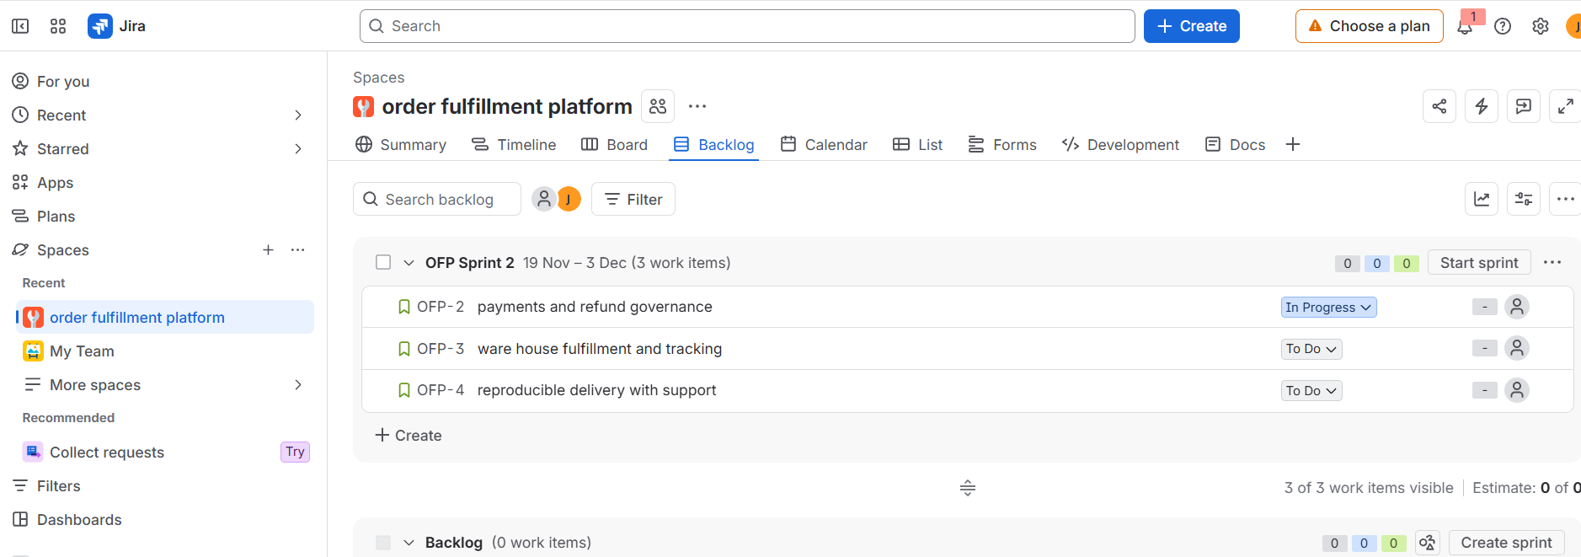
Figure 3.1: Jira Project Board Showing the Four Product Epics
ID | User story | Epic | Priority | Points | Dependency | Owner | Acceptance criteria
S01 | Role-based login | E1 | Must | 3 | None | Security | Valid users can sign in; customer, picker, support and finance roles see only permitted pages/actions; invalid credentials are rejected and access attempts are logged.
S02 | Place order and reserve stock | E1 | Must | 5 | S01 | Order API | A valid order reserves available stock with an expiry; an unavailable item is rejected; concurrent requests cannot reserve more units than exist; stock never becomes negative.
S03a | Payment idempotency key and local stub | E2 | Must | 2 | S02 | Payments | Repeated requests with the same key return the same payment result; one order creates at most one payment intent; failure leaves a recoverable local order.
S03b | Payment sandbox adapter | E2 | Must | 3 | S03a; sandbox available week 4 | Payments | Sandbox success and failure responses map to documented states; retries remain idempotent; no real card data is stored.
S04 | Warehouse pick list | E3 | Must | 3 | S02 | Inventory | Picker sees only paid, reserved orders assigned to that warehouse; quantities and item identifiers match the order.
S05 | Dispatch and audited status transitions | E3 | Must | 5 | S03a; S04 | Order API | Only allowed transitions are accepted; each transition stores actor, time and prior/new state; invalid transitions are rejected.
S06 | Customer tracking page | E3 | Must | 3 | S05 | Frontend | Customer sees paid, picked, dispatched and delivered milestones only; status labels are keyboard accessible and screen-reader readable.
S07 | Return request | E2 | Must | 3 | S05 | Order API | Only the order owner can request a return; the return window rule is checked; request and reason are recorded.
S08 | Role- and amount-based refund approval | E2 | Must | 5 | S03a; S07 | Security / Finance | Support cannot approve; an authorized reviewer can approve within configured limits; decision, actor, amount, timestamp and reason are audited.
S09a | Local build and smoke checks | E4 | Must | 3 | S01; S02 | DevOps | A clean source checkout builds; core health check and basic order test pass; build instructions are documented.
S09b | Pipeline hardening | E4 | Should | 2 | S09a | DevOps | Automated checks run on changes; failed checks prevent promotion; build artefacts are traceable to a source revision.
S10 | Support order lookup | E4 | Should | 3 | S05; S07; S08 | Frontend | Authorized agent finds an order and views its current status, return state and refund state without exposing payment secrets.
S11 | Fixed-threshold low-stock alert | E4 | Should | 3 | S04 | Inventory | A configured threshold creates one alert per item when stock crosses the threshold; repeated refresh does not create duplicate alerts.
S12 | Barcode pick confirmation | E3 | Should | 3 | S04; scanner arrives week 5 | Inventory | A valid scan confirms the expected item; a wrong item is rejected and recorded; manual fallback remains available.
S13 | Sales analytics dashboard | E4 | Could | 3 | S05 | Frontend / Data | Totals reconcile to order records and show the reporting period; deferred until core operational data is reliable.

The backlog contains four epics and fifteen refined story slices. The original payment story and build story are split into smaller slices to respect the gateway date and the provisional capacity ceiling. The first-release core is S01, S02, S03a, S03b, S04, S05, S06, S07, S08 and S09a. S09b, S10, S11 and S12 are included as capacity and hardware permit; S13 is deferred. The final release must still preserve the complete order-to-refund journey.

3.3 Two stakeholder-priority conflicts and decisions
1. Warehouse accuracy versus management analytics: warehouse staff need stock reservation and pick-list accuracy, while management may prefer an early sales dashboard. S02 and S04 remain Must because overselling causes failed orders and refunds; S13 is Could and deferred until order data is trustworthy.
2. Finance control versus fast customer handling: support agents want quick refund completion, while finance requires approval authority and auditability. S08 remains Must even though it adds a control step; support can initiate and track a refund but cannot approve it. This protects funds and makes accountability visible.

3.4 Definition of Ready (DoR)
1. The user, business outcome and affected role are identified.
2. Acceptance criteria include at least one success case and one negative or boundary case.
3. Dependencies, interface contracts and required test data are identified.
4. Privacy, authorization and accessibility questions relevant to the story are resolved.
5. The story is small enough to complete and verify within one sprint.
6. The responsible role and estimate are recorded; external access or hardware dependencies have an owner and expected date.

3.5 Definition of Done (DoD)
1. Code is peer-reviewed and merged to the agreed branch.
2. Relevant unit, integration, negative, regression and security tests pass.
3. Persistent state, server-side authorization and audit fields are verified.
4. No real customer data, card number or secret is used in screenshots or test evidence.
5. User-facing labels are readable; keyboard access and screen-reader semantics are checked.
6. Build and deployment instructions are updated and a clean build is reproducible.
7. Acceptance evidence, test result and issue links are attached to the Jira story.
8. Product owner or delegated stakeholder accepts the outcome; unresolved critical defects block Done.

3.6 Illustrative Jira artefacts
The following board and backlog extracts are illustrative Jira-style mock-ups derived from the story list above. They show the fields that should be created in Jira; they are not screenshots of a live Jira account.
Jira field | Example value
Project | FULFILIQ – Omnichannel Order Fulfilment
Epic | E1 – Order and stock core
Issue key | FULFILIQ-2 / S02
Issue type | Story
Summary | Place order and reserve stock
Priority | Highest / Must
Estimate | 5 story points
Assignee | Order API engineer
Linked issue | Blocks S04; depends on S01
Acceptance criteria | Reservation expiry; reject unavailable stock; concurrency invariant
Sprint | Sprint 1 – Secure ordering foundation
Status | In Progress → Review → Test → Done

Illustrative Jira issue-detail field set – create equivalent fields in the selected Jira project.
READY (WIP n/a) | IN PROGRESS (WIP 4) | REVIEW (WIP 2) | TEST (WIP 2) | BLOCKED | DONE
S01, S02, S03a, S04, S09a | S02, S04 | S01 | — | — | —

Illustrative Sprint 1 board snapshot before simulation; not a live Jira screenshot.
Task 3 conclusion: the backlog has explicit epics, user stories, acceptance criteria, priority, relative estimates, dependencies and owners. The DoR and DoD protect privacy, accessibility, authorization and test quality. The first release prioritizes a complete operational journey over optional analytics.

TASK 4 – CREATE A CAPACITY-BASED RELEASE PLAN AND DELIVERY WORKFLOW
Design the four-sprint release plan using explicit assumptions about team availability and capacity.
- Define a goal for each sprint.
- Select work that fits the assumed capacity.
- Explain your estimation method and avoid treating story points as fixed hours.
- Represent dependencies and cross-functional responsibilities, including the week-four gateway and week-five scanner constraints.
- Create a development workflow in the selected tool with statuses, transition rules and completion checks. Distinguish this workflow from the operational order lifecycle.
- Set and justify work-in-progress limits where applicable.
- Define how blocked work, urgent requests and unfinished stories will be handled.
- Show how the selected features collectively achieve the product goal.
Evidence Expected
Release plan, capacity assumptions, sprint goals, selected-tool board or workflow, work-in-progress policies and dependency-management decisions.

4.1 Capacity assumptions and estimation
The initial team has seven members. Each two-week sprint has ten working days. At six focused hours per person per day, nominal capacity is 7 × 10 × 6 = 420 hours. A 20% reserve (84 hours) is retained for meetings, stakeholder clarification, integration, unplanned defects and review. Focused planning capacity is therefore 420 − 84 = 336 hours per sprint.
Story points represent relative complexity, uncertainty and effort. They are not converted into fixed hours. Because no historical velocity exists, the first sprint uses a provisional ceiling of 16 points. The team must recalibrate after Sprint 1 using completed, accepted work and actual availability.

4.2 Four-sprint release plan
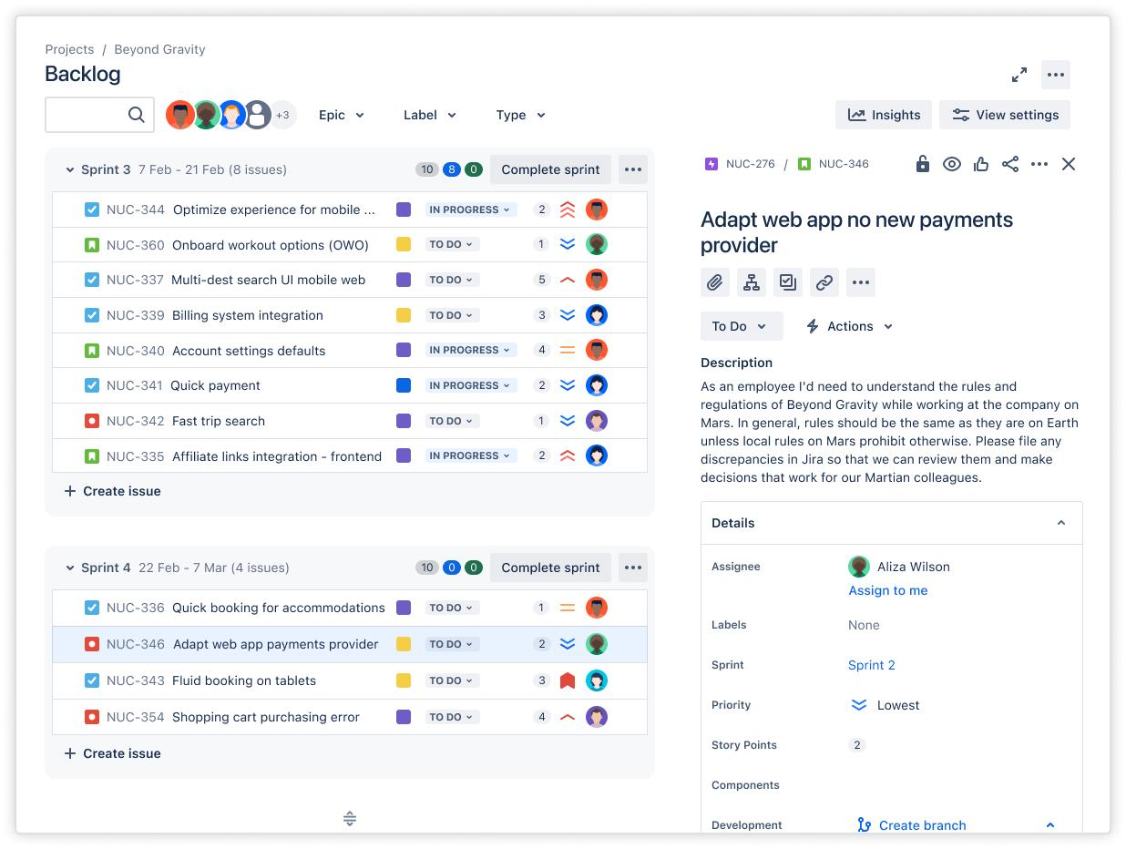
Sprint / weeks | Sprint goal | Selected stories | Points | Dependency and acceptance focus
Sprint 1  Weeks 1–2 | Secure ordering foundation | S01, S02, S03a, S04, S09a | 16 | Role permissions; reservation expiry and concurrency; payment stub/idempotency; pick-list rules; clean local build.
Sprint 2  Weeks 3–4 | Dispatch, tracking and stock alert foundation | S05, S06, S11, S09b | 13 | Use the local payment stub; validate legal status transitions and audit history; customer-visible milestones; low-stock threshold; pipeline checks.
Sprint 3  Weeks 5–6 | Sandbox payment, controlled returns and scanning | S03b, S07, S08, S12 | 14 | Gateway sandbox available from week 4; scanner device arrives week 5; verify return window, refund approval and scan rejection.
Sprint 4  Weeks 7–8 | Support visibility, hardening and release rehearsal | S10 | 3 | Complete support lookup; regression, security and accessibility checks; end-to-end release rehearsal; absorb carryover.

The initial unadjusted Sprint 1 selection was S01, S02, S03, S04 and S09 for 21 points, above the provisional 16-point ceiling. To correct this, S03 is split into S03a (2 points, local idempotency and stub) and S03b (3 points, sandbox adapter), while S09 is split into S09a (3 points, local build and smoke checks) and S09b (2 points, pipeline hardening). S03b moves to Sprint 3 because the gateway sandbox becomes available in week four. The revised sprint totals are 16, 13, 14 and 3 points. S13 analytics is deferred.
The low Sprint 4 estimate is intentional. It creates room for carryover, regression testing, security verification and a release rehearsal. It is not evidence that three points are enough for all possible defects.

4.3 Dependency sequence and cross-functional responsibilities
Sequence | Dependency / timing | Responsible roles
1 | S01 establishes roles and permissions before protected operations are exposed. | Security, frontend, QA.
2 | S02 depends on S01 and establishes the reservation record and expiry rule. | Order API, inventory/data, QA; warehouse stakeholder confirms policy.
3 | S03a depends on S02 and provides a local payment contract and idempotency behaviour before gateway access. | Payments/security, order API, QA.
4 | S04 depends on S02; pick lists use reserved and paid order records. | Inventory/data, warehouse stakeholder, QA.
5 | S05 depends on the local payment state from S03a and valid pick-list state from S04. | Order API, frontend, QA.
6 | S06 depends on S05; customer tracking displays approved milestones. | Frontend, accessibility reviewer, QA.
7 | S03b uses gateway sandbox access from week four; S12 uses scanner device from week five. | Payments/security and inventory, with QA.
8 | S07 and S08 depend on order status and payment state; finance approves policy and amount limits. | Order API, security, finance reviewer, QA.
9 | S10 depends on order, return and refund states being available and authorized. | Frontend, support stakeholder, QA.

4.4 Development workflow and transition rules
Status | Entry rule | Exit rule
Ready | DoR satisfied; acceptance criteria, owner, estimate and dependencies recorded. | A team member pulls it only when a development WIP slot is available.
In Progress | Work started; assignee and target outcome visible. | Implementation complete and review evidence attached → Review; dependency issue → Blocked.
Review | Code and test design available for peer review. | Review approved → Test; changes requested → In Progress.
Test | Acceptance build deployed to test environment; positive and negative cases available. | All checks pass → Done; defect found → In Progress; external dependency → Blocked.
Blocked | Reason, owner, date and next action recorded; remains counted in WIP. | Dependency resolved and owner confirms next action → previous active state.
Done | DoD satisfied and product acceptance recorded. | No transition out except a new defect issue or explicit reopen with reason.

This is the software-development workflow. It is different from the operational order lifecycle, which is: Created → Stock Reserved → Payment Confirmed → Picking → Dispatched → In Transit → Delivered → Return Requested → Refund Pending Approval → Refunded. The operational lifecycle must validate legal state transitions independently of Jira issue status.

4.5 WIP limits and exception policies
Column | WIP limit | Reason
In Progress | 4 | Prevents excessive parallel development across seven people.
Review | 2 | Keeps peer review from becoming a large queue.
Test | 2 | One QA engineer is the narrowest specialist capacity; finish tests before pulling more work.
Shared integration lane | 2 | Used for payment/order API integration and later cross-team integration.
Expedite | Maximum 1 | Reserved for a critical security, payment duplication or stock-integrity issue; equivalent planned work must be removed.

Blocked items remain counted against the active WIP limit. A blocked story must not be moved back to Ready merely to make the board appear healthy. Unfinished work returns to the ordered backlog with its remaining acceptance criteria visible; it is not marked partly Done and is not counted twice as new completed velocity. Urgent work is accepted only when the product lead identifies the risk and removes equivalent scope.

4.6 Product-goal coherence
The selected stories connect checkout and stock reservation to payment, picking, dispatch, tracking, returns and refund approval. S10 gives support visibility over the resulting status. The release therefore addresses the three operational priorities: accurate stock and pick lists, visible order/return progress, and controlled auditable refunds. Analytics is deferred because it does not repair a broken order journey.
Task 4 conclusion: the plan respects a provisional capacity limit, sequences work around the week-four gateway and week-five scanner, and distinguishes development flow from operational order states.

TASK 5 – SIMULATE DELIVERY AND VALIDATE THE DESIGN
Simulate the first sprint using a documented sequence of at least ten work events, such as starting a story, identifying a dependency, encountering a defect, receiving clarification or completing a review.
- Before simulation, predict where a bottleneck is most likely to occur.
- Identify which planning or workflow rule should help control it and what evidence would indicate that the rule is effective.
- Update the selected management tool to reflect the simulated events.
- Record suitable indicators such as completed versus planned work, blocked time, cycle time, work in progress or reopened stories.
- Use the results to identify a limitation in your original plan and create an improvement for the next sprint.
Evidence Expected
Prediction, event log, management-tool updates, at least three delivery indicators, interpretation of results and a revised planning or workflow decision.
All simulated results must be clearly labelled. Do not present simulated activity as actual team delivery.

5.1 Predicted bottleneck and control rule
Before simulation, the predicted bottleneck is the test queue and the hand-off between stock reservation and payment. S02, S03a and S04 converge on persistent order and stock state, while one QA engineer must verify concurrency, idempotency and authorization. A two-item Test WIP limit and a finish-before-start pull rule should expose waiting early.
Evidence that the rule is helping would include a visible Test queue that never exceeds two, reduced waiting time, fewer stories reopened after acceptance, and blocked items with named owners and next actions. These are indicators to inspect, not proof that WIP limits alone caused an improvement.

5.2 Sprint 1 event log – simulated
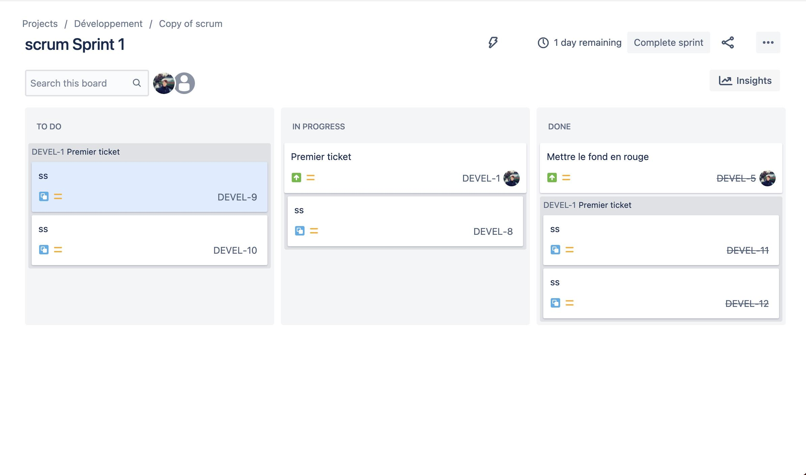
The following sequence is a simulated first-sprint exercise, not actual delivery by a real team.
Event | Simulated action | Jira-style effect / evidence
1 | Start S01 and S02. | Two development items are active; both have owners.
2 | Clarify the stock-reservation expiry rule with the warehouse representative. | S02 acceptance examples become testable.
3 | Complete S01 implementation. | S01 moves to Review.
4 | Review finds a missing expired-session negative test. | S01 returns to In Progress for correction.
5 | Start S04 against the agreed stock stub. | Three development items are active; WIP remains below four.
6 | Complete S02 implementation. | S02 moves to Review.
7 | Repair S01 and test role permissions. | S01 passes checks and becomes Done.
8 | Concurrency test finds two orders attempting to reserve the last unit. | S02 is held in Test until the reservation lock is corrected.
9 | Review and complete S04 against the reserved-order test data. | S04 becomes Done.
10 | S03a payment-key slice is blocked by the S02 reservation defect. | Blocker, owner and next action are recorded; blocked work remains visible.
11 | Repair the reservation lock and repeat concurrency tests. | S02 becomes Done after the stock invariant passes.
12 | S09a local build passes smoke checks, but deployment notes are missing; S03a remains unfinished. | S09a is not marked Done; S03a and S09a are carried over.

5.3 Illustrative Jira updates after event 9 and event 12
Status | After event 9 | After event 12
Ready | Remaining unstarted Sprint 1 items only. | Carryover returned to ordered backlog with reason.
In Progress | S03a; S09a; no more than four active items. | S03a and S09a unfinished; owner and next action recorded.
Review | — | —
Test | S02 concurrency retest; Test WIP not above 2. | S02 passed and moved to Done.
Blocked | S03a blocked by S02 reservation defect. | Blocker resolved; S03a remains unfinished for implementation/test.
Done | S01 and S04. | S01, S02 and S04.

Illustrative Jira-style board state derived from simulated events; not a live Jira screenshot.

5.4 Delivery indicators – simulated results
Indicator | Simulated result | Interpretation
Planned versus completed | 16 points planned; 11 accepted points completed; 68.75% completion. | S01 (3), S02 (5) and S04 (3) completed. S03a (2) and S09a (3), five points total, carry over.
Blocked effort | Two story-days on S03a. | The payment slice depended on stock reservation correctness; dependency sequencing and early contract tests matter.
Test queue | Maximum two items; simulated wait reduced from two days to one day after the team applied finish-before-pull. | The WIP rule exposed waiting. The small simulated sample cannot establish causation.
Reopened / reworked stories | Two stories needed rework before acceptance. | S01 needed a negative permission/session test; S02 needed a concurrency/expiry correction. The Ready checklist needs explicit negative cases.

Completion ratio = 11 ÷ 16 × 100 = 68.75%, rounded to 68.8%. This is a simulated scope-completion ratio, not a measure of individual productivity.

5.5 Interpretation and improvement for Sprint 2
The event log shows that the reservation rule was a dependency for payment and picking. The team should not start dependent work merely because a developer is available; it should verify that the upstream contract and invariant are stable. The test queue reached its limit, and the payment slice remained blocked. The two rework cases show that the Definition of Ready needs negative examples, particularly for expired sessions, invalid permissions and concurrent reservations.
1. Plan no more than ten new points plus the five-point carryover until actual availability and QA capacity are reviewed.
2. Split S05 into a three-point status API slice and a two-point notification slice if the combined story is too large.
3. Schedule a short daily API-and-QA pairing slot for reservation and payment contract tests.
4. Move S11 to Sprint 3 if the Sprint 2 forecast shows that dispatch and tracking are at risk.
5. Keep S03b tied to the week-four sandbox availability and preserve local replay tests if the sandbox is delayed.
Task 5 conclusion: the simulated results support a smaller Sprint 2 commitment, stronger negative-case readiness and earlier integration pairing. All figures remain explicitly simulated.

TASK 6 – REDESIGN DELIVERY UNDER CHANGED CONDITIONS
Changed Requirement
At the end of the first simulated sprint, the organization introduces the following changes:
- Two additional regional warehouses must use the platform.
- A second seven-member development team joins the project.
- The payments engineer from the original team becomes unavailable for the remaining period.
- Region-specific tax, shipping and refund-approval rules are now required.
- The festival-sale release deadline remains unchanged.
Create a revised strategy that coordinates both teams, preserves a useful first release and manages the new constraints.
Component | Required Work | Marks
A. Diagnose the impact | Identify affected assumptions, capacity, scope, dependencies and risks using evidence from your original plan. | 2
B. Define redesign objectives | Establish measurable objectives for the revised strategy, including achievable scope and coordination expectations. | 2
C. Create the revised strategy | Redesign backlog priorities, team responsibilities, release sequencing and dependency coordination. Incorporate justified scaled Agile and Lean practices. | 4
D. Validate the redesign | Simulate at least five additional events and compare the revised strategy with the original using equivalent indicators. | 2
E. Defend the decision | Explain benefits, limitations and trade-offs. Show why the revised strategy remains feasible under the unchanged deadline. | 2
You may use selected SAFe-inspired coordination practices or another justified scaled Agile approach. Explain what you adopt and why it fits this project.
Evidence Expected
Impact analysis, measurable redesign objectives, revised management-tool artefacts, cross-team coordination design, comparative simulation evidence and an evidence-based defence

6.1 A. Diagnose the impact
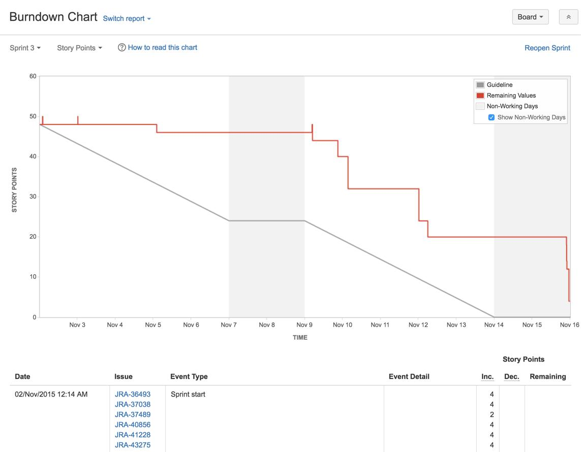
At the end of the simulated first sprint, the organization introduces two additional regional warehouses, a second seven-member development team, the loss of the original payments engineer, region-specific tax, shipping and refund-approval rules, and an unchanged festival-sale deadline. These changes affect the original assumptions in several ways.
Change | Impact on original plan | Risk / response
Two additional regional warehouses | One warehouse-oriented stock and fulfilment rule is no longer sufficient; tax, shipping and refund policies vary by region. | Use region configuration and policy tables; test at least two representative regions end to end.
Second seven-member team joins | More nominal people are available, but onboarding and shared API coordination reduce immediate capacity. | Do not assume throughput doubles; reserve time for onboarding and integration.
Original payments engineer unavailable | Payment knowledge and ownership are lost during a critical dependency. | Assign a new payment API owner from Team B and conduct paired handover using contract tests.
Regional tax, shipping and refund approval | Order totals and refund permissions need region-aware rules. | Define a shared policy interface and region-specific configuration; finance approves test examples.
Festival deadline unchanged | There is no extra release time for the increased scope. | Protect the complete order journey and defer analytics and promotional scope.

Capacity is recalculated for the next sprint. Team A has six available members: 6 × 10 days × 6 hours = 360 nominal hours. Team B has seven members but is assumed to be only 60% available during onboarding: 7 × 10 × 6 × 0.60 = 252 nominal focused hours before coordination reserve. Combined nominal availability is 612 hours. A 25% reserve for cross-team coordination, onboarding questions, integration and defects leaves 612 × 0.75 = 459 focused hours. This is approximately 1.37 times, or 1.4 times, the original 336 focused hours—not twice the throughput.

6.2 B. Measurable redesign objectives
1. Publish one versioned order, payment and refund API contract before both teams implement dependent stories.
2. Keep tax, shipping and refund thresholds in region-specific configuration; do not fork the common order workflow.
3. Demonstrate one complete synthetic order-to-delivery-to-refund journey in each of two representative regions before release.
4. Assign one integration owner and keep no more than two cross-team dependencies actively in implementation at one time.
5. Resolve all critical stock-integrity, duplicate-payment and refund-authorization defects before release; zero unresolved critical defects is the release gate.
6. Reserve 40% of Team B's first sprint for onboarding, contract tests and integration; use the remaining capacity only for ready work.
7. Keep the festival-sale date unchanged and protect the release by deferring S13 analytics and broad promotional features.

6.3 C. Revised strategy: backlog, ownership and sequence

Team responsibilities
Team / role | Ownership | Boundary and collaboration
Team A – six available original members | Order core, stock reservation, pick list, dispatch, tracking and end-to-end regression. | Owns canonical order state and stock invariant; exposes documented APIs to Team B.
Team B – seven new members | Regional tax/shipping policy, refund workflow, support UI and delivery automation. | First sprint reserves 40% for learning and integration; takes over payment API through paired handover.
Integration owner | Coordinates shared API contracts, integration lane and cross-team dependency review. | Approves contract changes and resolves duplicate ownership before work starts.
Product lead | Maintains one ordered backlog and release scope across both teams. | Accepts trade-offs; does not create competing team backlogs.
Finance and warehouse representatives | Approve regional policy examples and operational acceptance. | Attend targeted weekly clarification and integrated demo.

Revised backlog priorities
Priority | Retained / changed work | Decision
Must | S01, S02, S03a, S03b, S04, S05, S06, S07, S08, S09a and S10. | Preserve complete order-to-refund journey and visible support status.
Must – new regional slices | Region policy configuration for tax, shipping and refund thresholds; two-region end-to-end tests. | Add only the minimum configuration and validation needed for the two new warehouses.
Should | S09b pipeline hardening, S11 low-stock alert and S12 barcode scan, subject to midpoint capacity. | Deliver only after shared contract and end-to-end journey are stable.
Could / deferred | S13 sales analytics, broad promotions and nonessential regional customization. | Defer to protect the fixed release date.

Scaled Agile and Lean coordination
1. Maintain one shared product backlog and one integrated release goal; each team may use its own task view but cannot create conflicting definitions of Done.
2. Use a twice-weekly 20-minute dependency review with team representatives and the integration owner. Review only cross-team blockers, contract changes and integration readiness.
3. Run one integrated demonstration per sprint using the same synthetic order journey across the two selected regions.
4. Version the API contract and region-policy schema. Contract changes require review by both owning teams before implementation.
5. Use a shared integration lane with WIP limit two. A dependency cannot enter the lane unless its upstream contract test passes.
6. Reserve 40% of Team B's first sprint for onboarding, codebase walkthrough, security/privacy review and payment API pairing.
7. Use one release board and shared acceptance evidence. Team-level boards must link to the same epics and stories.
8. Apply a finish-before-start rule to high-risk payment and refund work; do not increase WIP merely because the second team has joined.

Revised release sequence
Period | Team A focus | Team B focus | Integrated checkpoint
Remaining Sprint 2 | Stabilize order/stock API and dispatch state; complete reservation concurrency tests. | Onboard; review API; create region policy model and test fixtures; pair on payment adapter. | Shared contract approved; one region policy example passes.
Sprint 3 | Complete tracking, picking and order-state integration. | Take payment adapter handover; implement tax/shipping configuration and refund approval rules. | Sandbox and local adapter tested; integrated demo in two regions.
Sprint 4 | End-to-end regression, stock integrity and release rehearsal. | Support lookup, regional refund test coverage, accessibility and deployment support. | Two-region order-to-refund acceptance; zero critical defects.

6.4 D. Validate the redesign – five additional simulated events
The following events are simulated to test whether the revised coordination rules handle the changed conditions. They are not records of actual team delivery.
Event | Additional simulated event | Revised response and evidence
1 | A region requests a special tax and shipping rule. | Add values to the region policy table and run policy tests; do not duplicate the order-processing code.
2 | Team B proposes an address payload that conflicts with Team A's API contract. | The integration owner pauses implementation, compares contract examples and approves one versioned field definition.
3 | The original payments engineer becomes unavailable. | A Team B engineer pairs with the original team before handover; idempotency contract tests and replay fixtures become the handover evidence.
4 | Gateway sandbox access is delayed again. | Continue against the local payment adapter and replay tests; keep sandbox integration blocked and visible rather than pretending it is complete.
5 | Integrated demo finds that a support-agent role can approve a refund. | Release gate blocks refund approval; security owner corrects role checks and QA reruns negative authorization tests.
6 | Midpoint capacity review shows the teams cannot finish every optional item. | Keep S13 analytics and promotional work deferred; move S11 low-stock alert out if needed to protect the core journey.

6.5 Comparative simulation indicators
Equivalent indicator | Original simulated Sprint 1 | Revised simulated sprint | Interpretation
Planned / completed points | 16 planned; 11 completed. | 22 planned; 18 completed across both teams. | The revised simulation shows a higher completion ratio, but it is a scenario comparison, not proof of real productivity.
Completion ratio | 11 ÷ 16 = 68.8%. | 18 ÷ 22 = 81.8%. | Improved simulated completion under the revised scope and capacity assumptions.
Blocked story-days | 2 story-days. | 1 story-day. | Shared contract ownership and dependency review reduce simulated waiting.
Reopened / reworked stories per completed story | 2 / 3 = 0.67. | 2 / 6 = 0.33. | The revised DoR and contract tests reduce the simulated rework ratio.

The comparison uses equivalent indicators, but the sample sizes and assumptions are small. The revised values are simulated and cannot establish that adding a team caused better performance. A real pilot must measure actual throughput, cycle time, blocked time, escaped defects and workload.

6.6 E. Defend the redesign: benefits, limits and trade-offs
The redesign is more feasible than simply doubling the team because it recognizes onboarding and coordination overhead. Team A protects the common order and stock model; Team B takes region configuration, refund workflow, support and the payment handover. A shared contract, integration owner, twice-weekly dependency review and integrated demo reduce conflicting interfaces. Region-specific policy data is configured rather than copied into separate code paths.
The release remains credible only if the organization accepts a narrower first release: the complete order-to-refund journey in two representative regions is protected, while analytics and broad promotional features remain deferred. S11 and S12 are conditional and may be removed if midpoint evidence shows insufficient time. The gateway remains a risk; the local adapter and replay tests preserve development progress but do not replace final sandbox validation.
The limitations are significant. The 459-hour estimate depends on the stated availability assumptions, and Team B's 60% onboarding availability may be optimistic. Regional tax and refund rules require finance/legal confirmation. Shared APIs can still become bottlenecks, and a successful synthetic demo does not prove production-scale performance or payment security. The deadline is therefore feasible as a controlled, limited release, not as delivery of all nine modules at full depth.
Task 6 conclusion: the revised plan uses scaled coordination without introducing a heavy enterprise framework. It preserves the core journey, adds two-region policy validation, transfers payment ownership with evidence and protects the fixed deadline through explicit deferrals.

TASK 7 – INDIVIDUAL TECHNICAL REFLECTION
Explain:
- Which project-management decision you consider most significant and why.
- How your evidence influenced a change to the original strategy.
- Where your final design remains vulnerable.
- How you addressed an ethical concern involving privacy, workload, accessibility or transparency.
- What you would investigate next before using the strategy with a real development team.
Evidence Expected
A concise individual reflection demonstrating understanding of the created strategy and its limitations. Refer to your own artefacts and findings.

7.1 Most significant project-management decision
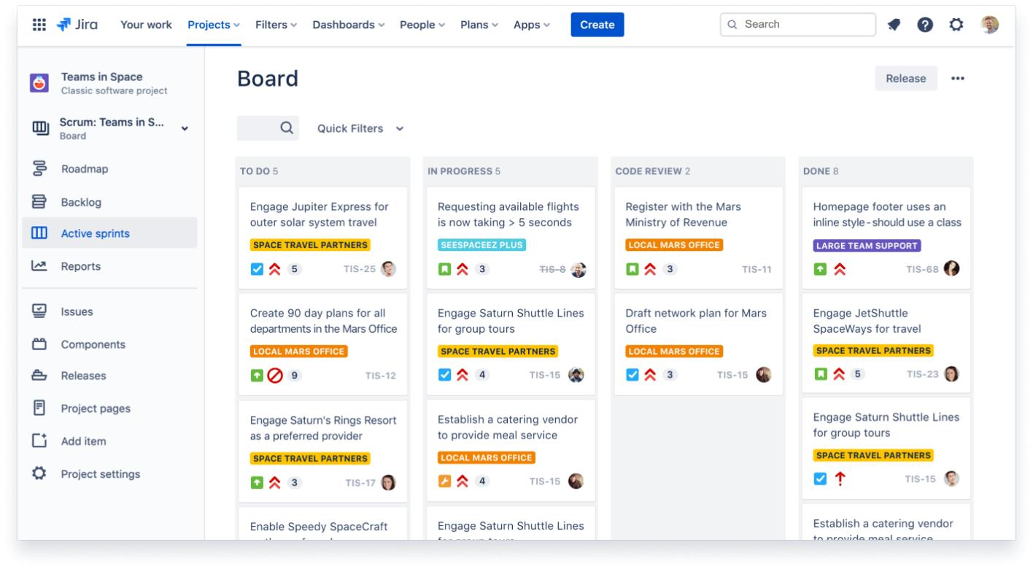
The most significant decision was to prioritize a complete order-to-refund journey instead of attempting all nine proposed modules at equal depth. This decision connects stock reservation, payment idempotency, picking, dispatch, tracking, returns and refund approval. A storefront-only or analytics-first release would not solve the retailer's principal operational failures.

7.2 How evidence changed the original strategy
The Sprint 1 simulation planned 16 points but accepted 11 points, with five points carried over. The event log showed that the S02 reservation defect blocked S03a payment work. This evidence led to a smaller Sprint 2 commitment, more explicit negative-case examples in the Definition of Ready, a daily API-and-QA pairing slot and visible carryover. The changed-condition simulation then reinforced the need for one shared contract and an integration WIP limit of two.

7.3 Remaining vulnerability
The largest remaining vulnerability is external payment-gateway uncertainty. A local adapter can test retry and idempotency logic, but the sandbox may behave differently from a live provider. Regional tax, shipping and refund rules also need authoritative confirmation. The schedule depends on timely stakeholder decisions and the assumption that Team B can reach 60% availability after onboarding.

7.4 Ethical concern and response
Privacy and transparency are addressed by using synthetic customer, order and payment data in all demonstrations; restricting screens and actions by role; avoiding card secrets in logs; and preserving an auditable human decision for refunds. Accessibility is addressed through readable milestone labels, keyboard navigation and screen-reader semantics. Workload fairness is supported by visible WIP, carryover and blocked work rather than treating unfinished work as individual failure. All simulated evidence is clearly labelled so it cannot be mistaken for actual delivery.

7.5 Next investigation before real use
Before using the strategy with a real team, I would measure actual order volume and concurrency, observe the warehouse reservation and picking process, obtain finance-approved regional refund/tax examples, test gateway latency and failure modes, confirm stakeholder availability, and validate Jira permissions and reporting. I would also run a short technical spike for the payment adapter and stock reservation lock, then replace provisional capacity assumptions with measured team availability and completed-story data.
Task 7 conclusion: the strategy is a reasoned planning design, not a production certification. Its value lies in connecting stakeholder needs, backlog priorities, capacity, workflow evidence and scope changes while making uncertainty visible.

FINAL RUBRIC CROSS-CHECK
Task | Rubric coverage included in this report | Status
1 – 5 marks | Six investigation questions; simulated stakeholder evidence; product goal; scope and exclusions; six measurable criteria; technical, operational, financial and schedule feasibility. | Addressed
2 – 6 marks | Two approaches compared; selected Scrum + Lean; seven responsibilities; cadence and escalation; WIP and flow controls; Jira versus GitHub Projects comparison and tool selection. | Addressed
3 – 8 marks | Four epics; fifteen story slices with acceptance criteria, priority, points, dependencies and owners; DoR; DoD; privacy/accessibility; two stakeholder conflicts; illustrative Jira artefacts. | Addressed
4 – 7 marks | Capacity calculation; four sprint goals and totals; week-four gateway and week-five scanner dependencies; workflow statuses and transition rules; WIP limits; urgent and unfinished work policies. | Addressed
5 – 7 marks | Pre-simulation bottleneck prediction; twelve simulated events; board updates; completion, blocked time, test queue and rework indicators; interpretation and next-sprint changes. | Addressed
6 – 12 marks | All five changed conditions; recalculated capacity; measurable objectives; team split; shared backlog/contracts; scaled coordination; six simulated events; equivalent comparison indicators; trade-offs and deadline defence. | Addressed
7 – 5 marks | Significant decision; evidence-driven change; vulnerability; ethical response; next investigation linked to the report artefacts. | Addressed

ACKNOWLEDGEMENT OF SOURCES AND TOOLS
Primary source: the uploaded “CSA10 Assignment 1 (Set B) – FulfilIQ Agile Delivery Strategy” document, including its task instructions, scenario assumptions, answer key and marking rubric. The report uses the source's scenario and permitted simulation approach. All additional numerical thresholds explicitly described as planning assumptions are proposed for this report and require validation with real stakeholders.
Tools and methods: Microsoft Word document generation; Jira-style backlog and workflow artefacts presented as illustrative tables; arithmetic calculations for capacity and simulated indicators. No live Jira project, Google Compiler run, production system, real stakeholder interview or real delivery measurement is claimed.

ITEMS TO CONFIRM BEFORE SUBMISSION
1. Fill in the student name, register number, programme/section, faculty name and submission date on the cover page.
2. If the faculty expects actual Jira evidence, create the Jira project and replace the illustrative Jira-style tables with genuine screenshots or an export showing epics, stories, priorities, estimates, dependencies, sprint and workflow.
3. The assignment tasks do not request a C program or Google Compiler output. Therefore no Google Compiler code/output screenshots are included; adding fabricated screenshots would misrepresent the evidence.
4. Confirm whether the faculty wants the selected Jira account's actual plan/access details and whether the proposed service-level thresholds should be adjusted to a class-approved value.
Additional Jira-style visual evidence (illustrative mock-ups)
The backlog view reflects the issue IDs, priorities, estimates and dependencies in the assignment's user-story table. The sprint board shows the sample Ready, In Progress, Review, Test, Blocked and Done workflow. These visuals are mock-ups, not screenshots from a live Jira account.
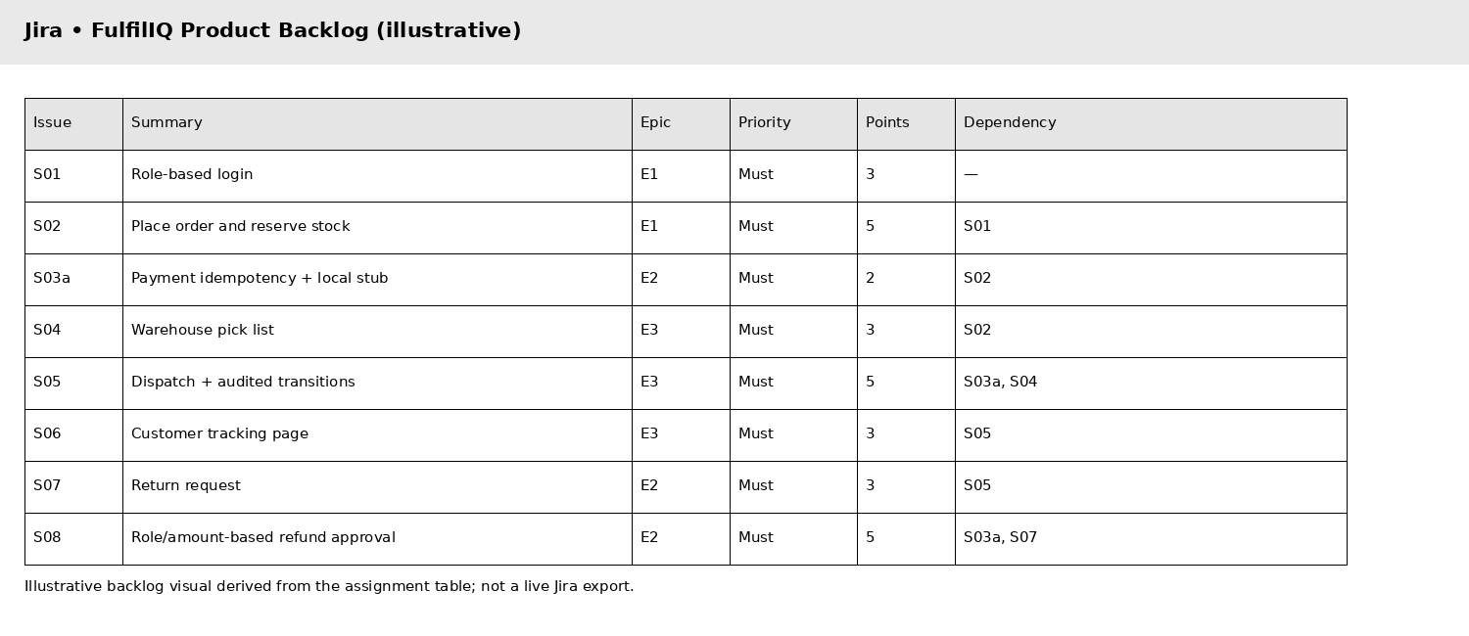
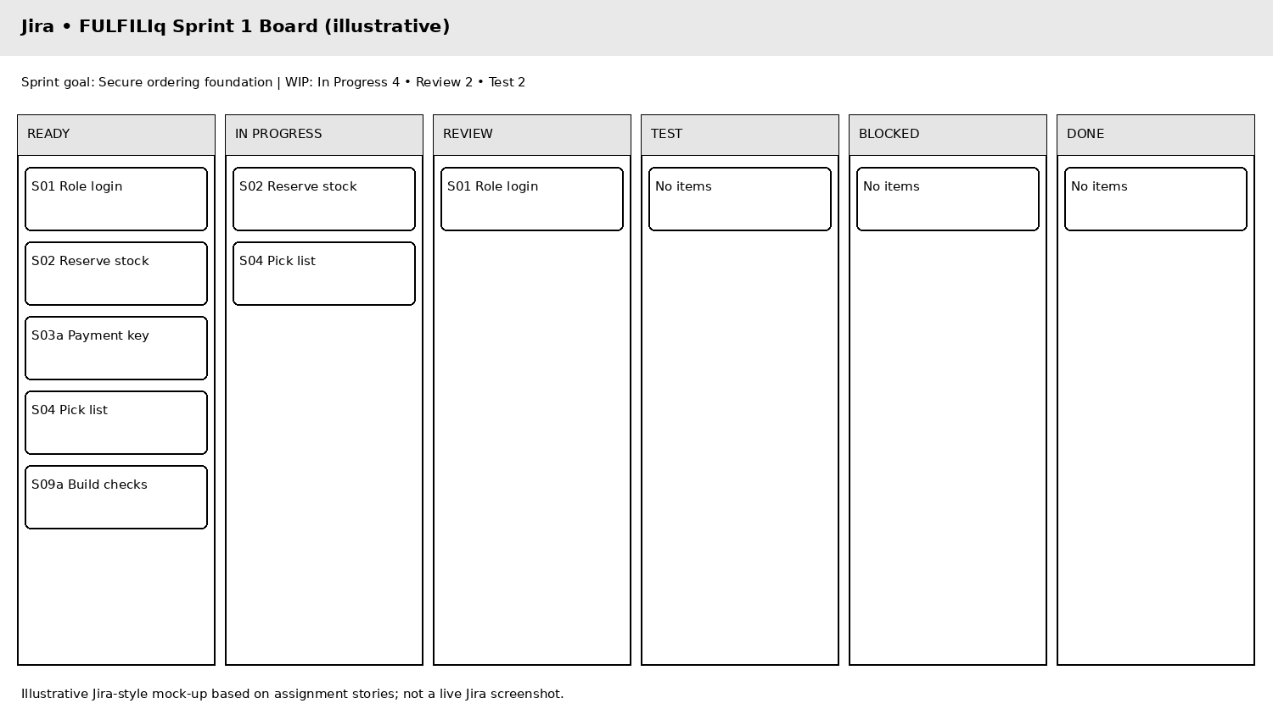

Appendix A – C Programming Implementations and Execution Evidence
The original seven tasks assess Agile planning and delivery. These C programs are supplementary demonstrations mapped to the FulfilIQ user stories in the assignment backlog; they are not specified as a required C deliverable in the task brief. Each program uses fixed sample data to demonstrate the corresponding rule. They are educational console prototypes, not production services.
Execution evidence: each program was compiled and executed locally with GCC using the C11 standard. The captures show the source code and its actual output. They are not screenshots from Google Compiler. The editable code listings can be copied into Google Compiler if the faculty specifically requires screenshots from that website.
Role-based login | S01 | Demo user role and role-specific permission.
Stock reservation | S02 | Accepts a request only when stock is available.
Payment idempotency | S03a | Repeated request key reuses the first result.
Warehouse pick list | S04 | Shows only paid orders for the selected warehouse.
Order status and tracking | S05, S06 | Checks a valid status transition and records an actor.
Return and refund approval | S07, S08 | Checks order ownership, return window, reviewer role and limit.

Appendix B – Evidence notes
The Jira visuals are illustrative mock-ups generated from the report's existing backlog and sprint plan. They are not proof of a live Jira project. If actual Jira evidence is required, create the project in the institution-approved Jira account and replace these visuals with screenshots of the live project, backlog and sprint board.
The C execution captures are genuine local GCC compile-and-run results. They are not Google Compiler screenshots. The complete editable source code is included in this appendix for copying into an online compiler.
MARK DISTRIBUTION
Task | Assessed Area | Marks
Task 1 | Problem investigation and measurable delivery outcomes | 5
Task 2 | Original Agile and Lean operating model | 6
Task 3 | Prioritized Jira backlog and acceptance criteria | 8
Task 4 | Capacity-based release plan and workflow | 7
Task 5 | Delivery simulation and evidence-based improvement | 7
Task 6 | Day-4 Design Challenge – scaled delivery redesign and validation | 12
Task 7 | Individual technical reflection | 5
TOTAL |  | 50

